MINUTES OF THE MEETING OF THE BOARD OF DIRECTORS
OF
AFRICAN SOLIDARITY CIVIC ORGANISATION NPC
(ASCO NPC)
Date of Meeting: 9/8/2026 13:00:02 PM
Venue: Durban, Kwazulu-Natal
1. OPENING AND WELCOME
The meeting of the Board of Directors of African Solidarity Civic Organisation NPC (ASCO NPC) was called to order by the Chairlady of the Board, Ms Busisiwe Makhosi Shandu.
The Chairlady welcomed all Directors and confirmed that the meeting was properly constituted, with the required quorum present to deliberate and adopt resolutions binding on the organisation.
The Chairlady stated that the purpose of the meeting was to consider and formally adopt the customised Memorandum of Incorporation (MOI) of ASCO NPC, ensuring that the organisation's governance framework reflects its founding principles, non-profit objectives, institutional values and future sustainability.
2. ATTENDANCE
The following Directors were present:
Name | Position
Ms Busisiwe Makhosi Shandu | Chairlady of the Board / Founder and Custodian of Founding Legacy
Mr Bhekisisa Shandu | Executive Director
Mr Thapelo Nelson Maqalika | Director: Head of ICT and Communications
Mr Khulekani Gumede | Director: People and Culture

3. APOLOGIES
No apologies were received.
4. DECLARATION OF INTEREST
All Directors present confirmed that they had no personal financial interests that conflicted with the matters tabled before the meeting.
5. PURPOSE OF THE MEETING
The Chairlady tabled the following objectives of the meeting:
5.1 To consider the customised Memorandum of Incorporation (MOI) prepared for African Solidarity Civic Organisation NPC;
5.2 To ensure that ASCO NPC has a governance framework aligned with the Companies Act 71 of 2008 and principles applicable to non-profit companies;
5.3 To formally recognise the contribution of the founder in establishing ASCO NPC and preserving its founding vision;
5.4 To strengthen governance systems required for engagement with regulators, donors, international partners and potential applications relating to Public Benefit Organisation (PBO) and Section 18A approval;
5.5 To confirm the roles, responsibilities and authority of the Board of Directors and Executive Management.
6. BACKGROUND AND CONSIDERATION OF THE CUSTOMISED MOI
The Board considered the customised Memorandum of Incorporation prepared for ASCO NPC.
The Board noted that the MOI is intended to serve as the organisation's principal governance instrument and provides clarity on:
•The purpose and objectives of ASCO NPC;
•The organisation's non-profit character;
•The authority and responsibilities of the Board of Directors;
•The separation between governance oversight and operational management;
•Ethical leadership and accountability;
•Protection of organisational assets and resources;
•Institutional continuity beyond individual office bearers;
•Compliance with legal and regulatory requirements.
The Board further noted that the customised MOI strengthens ASCO NPC's readiness to engage with funding institutions, government structures, international organisations and regulatory authorities.
7. RECOGNITION OF THE FOUNDER AND FOUNDING LEGACY
The Board formally considered the recognition of Ms Busisiwe Makhosi Shandu as Founder and Custodian of the Founding Legacy of African Solidarity Civic Organisation NPC.
The Board recorded that the recognition of the Founder is intended to preserve and honour:
•The founding vision of ASCO NPC;
•The contribution and sacrifice made during the establishment of the organisation;
•The principles, values and objectives upon which ASCO NPC was created.
The Board further resolved that:
7.1 Recognition of the Founder does not create ownership rights, personal control or financial entitlement over ASCO NPC;
7.2 ASCO NPC remains an independent non-profit company established for public benefit purposes;
7.3 The Founder's recognition exists to protect institutional memory, history and founding values for future generations;
7.4 Future leadership structures shall respect and uphold the founding principles of ASCO NPC.
8. CONFIRMATION OF GOVERNANCE STRUCTURE
The Board confirmed the following governance structure:
8.1 Chairlady of the Board
Ms Busisiwe Makhosi Shandu
The Chairlady shall provide leadership to the Board, ensure effective governance oversight and safeguard the founding principles and long-term vision of ASCO NPC.
8.2 Executive Director
Mr Bhekisisa Shandu
The Executive Director shall be responsible for:
•Implementation of Board resolutions;
•Day-to-day executive management of ASCO NPC;
•Coordination of organisational programmes and operations;
•Providing strategic leadership and institutional direction;
•Ensuring effective administration and execution of organisational objectives.
8.3 Director: Head of ICT and Communications
Mr Thapelo Nelson Maqalika
The Board resolved that Mr Maqalika shall:
•Coordinate ICT and communication functions of ASCO NPC;
•Manage communication-related administrative processes;
•Be specifically mandated to coordinate the submission and registration process of the adopted MOI with the Companies and Intellectual Property Commission (CIPC);
•Work directly with the Office of the Executive Director to ensure all required documentation, correspondence and regulatory requirements are properly managed.
8.4 Director: People and Culture
Mr Khulekani Gumede
The Board confirmed that Mr Gumede shall provide leadership and oversight relating to:
•People management;
•Organisational culture;
•Human capital development;
•Governance participation;
•Supporting effective institutional growth.
9. BOARD RESOLUTION: ADOPTION OF CUSTOMISED MOI
After thorough consideration and discussion, the Board unanimously adopted the following resolution:
RESOLUTION NUMBER: ASCO/BOD/MOI/2026/01
IT IS HEREBY RESOLVED THAT:
1. The Board of Directors hereby approves and adopts the customised Memorandum of Incorporation of African Solidarity Civic Organisation NPC.
2. The adopted MOI shall become the governing constitutional document of ASCO NPC and shall regulate the affairs, governance and administration of the organisation.
3. The Board confirms that the customised MOI reflects ASCO NPC's commitment to good governance, accountability, transparency, sustainability and compliance with applicable legislation.
4. Mr Thapelo Nelson Maqalika, Director: Head of ICT and Communications, is hereby authorised and mandated to coordinate the registration and submission process of the adopted MOI with CIPC.
5. Mr Thapelo Nelson Maqalika shall work directly with the Office of the Executive Director, Mr Bhekisisa Shandu, to ensure successful completion of all administrative and regulatory requirements.
6. The Executive Director shall provide executive oversight, institutional support and coordination necessary to implement this resolution.
7. The Chairlady of the Board and any authorised Director are empowered to sign documents necessary to give effect to this resolution.
10. IMPLEMENTATION OF THE RESOLUTION
The Board directed that:
10.1 The adopted MOI shall be submitted to CIPC through the appropriate channels;
10.2 All organisational policies, governance documents and operational frameworks shall be reviewed for alignment with the adopted MOI;
10.3 The governance framework shall support ASCO NPC's future applications, including engagements relating to SARS PBO status, Section 18A approval, donor compliance and international partnerships.
11. CLOSURE
There being no further matters for consideration, the Chairlady thanked all Directors for their participation and declared the meeting officially closed.
Time closed: 9/8/2026 14:18:05 PM
SIGNATURES OF THE FOUNDING MEMBERS / BOARD OF DIRECTORS
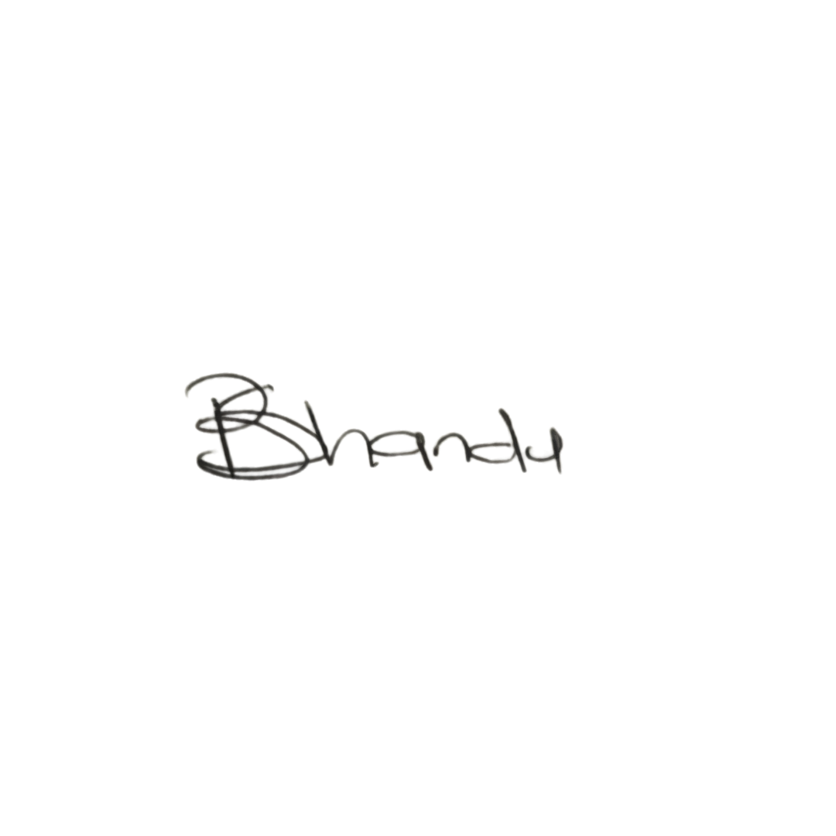  CHAIR LADY  Ms. Busisiwe Makhosi Shandu  Signature: ____________________________  Date: 8 September 2026 | 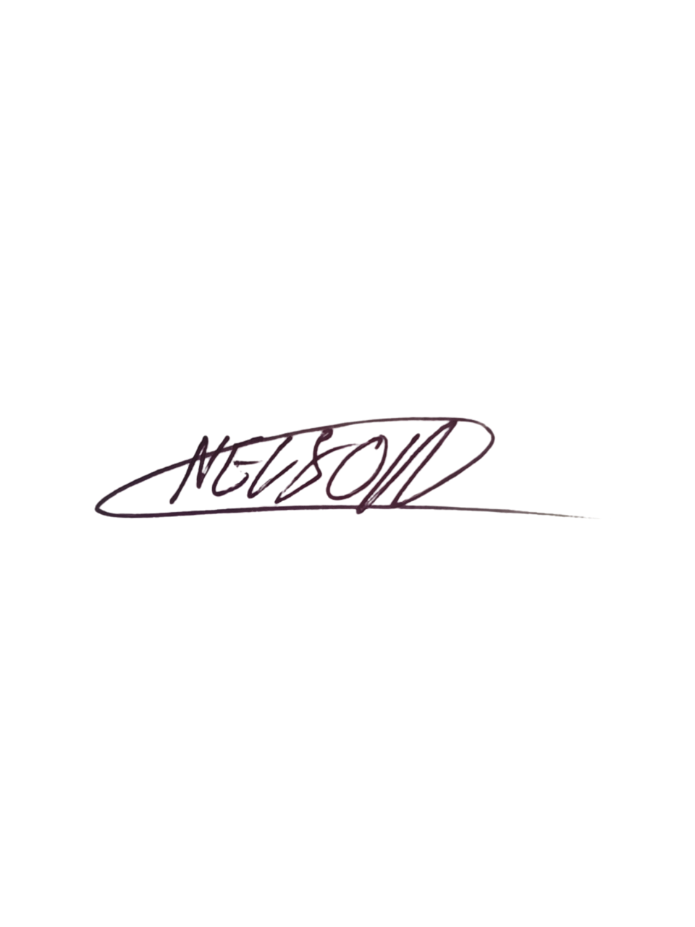  DIRECTOR: HEAD OF ICT AND COMMUNICATIONS  Mr. Thapelo Nelson Maqalika  Signature: ____________________________  Date: 8 September 2026
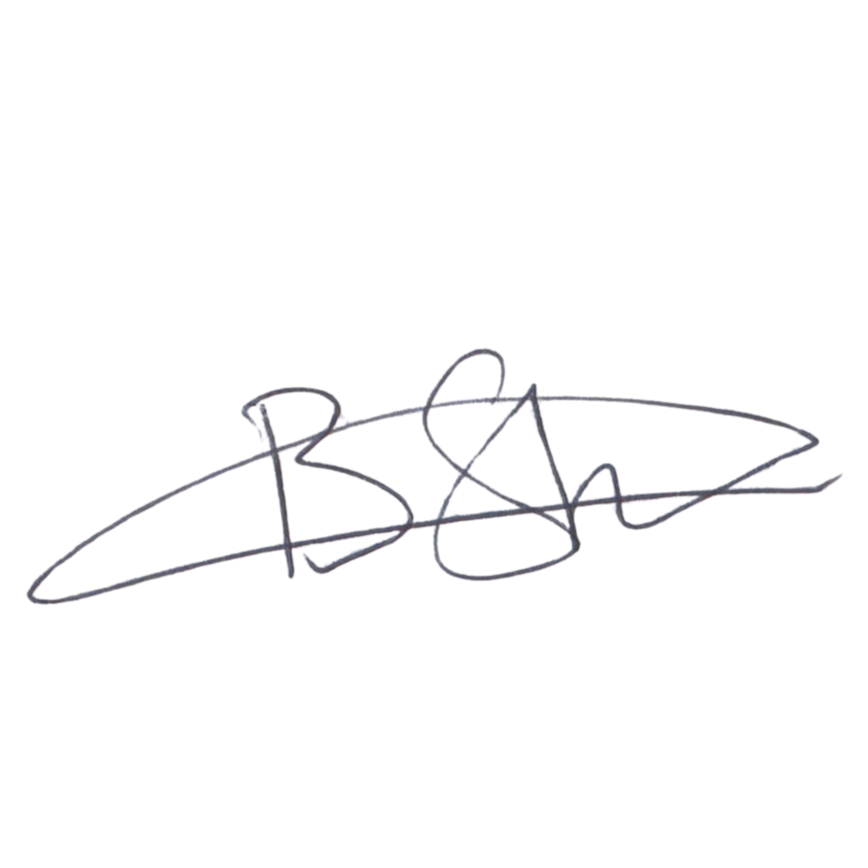  EXECUTIVE DIRECTOR  Mr. Bhekisisa Shandu  Signature: ____________________________  Date: 8 September 2026 | 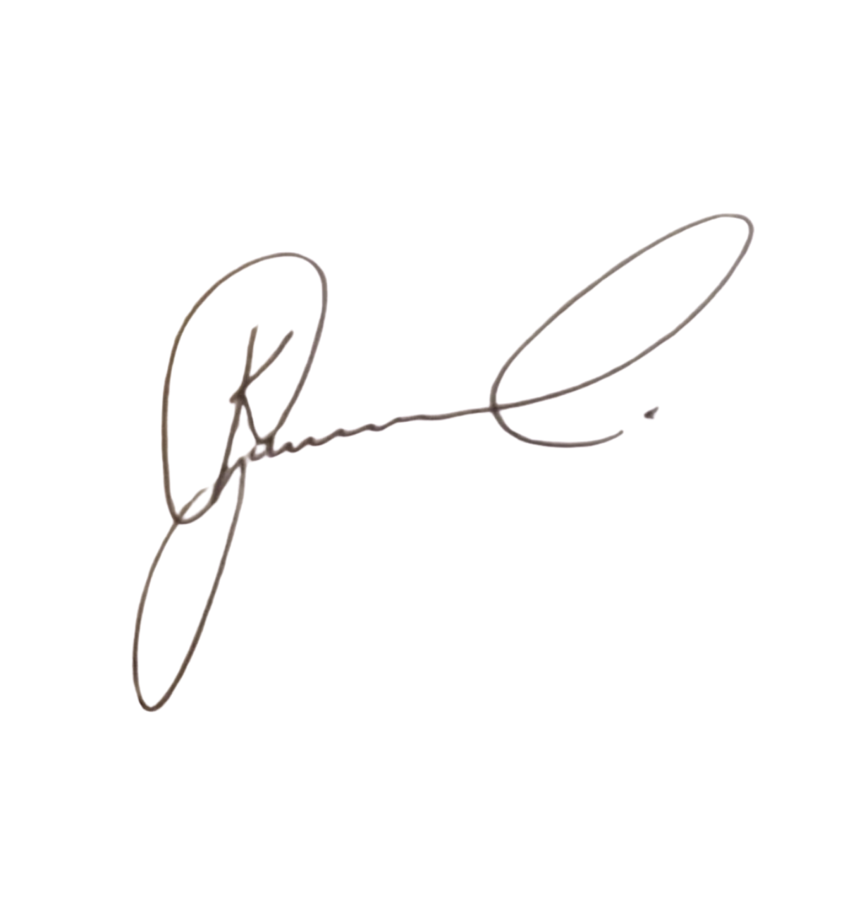  DIRECTOR: PEOPLE AND CULTURE / CHAIRPERSON: FINANCE AND PROCUREMENT COMMITTEE  Mr. Khulekani Gumede  Signature: ____________________________  Date: 8 September 2026

